DAYANANDA SAGAR UNIVERSITY

#### DEPARTMENT OF COMPUTER SCIENCE & TECHNOLOGY

#### SCHOOL OF ENGINEERING

**DAYANANDA SAGAR UNIVERSITY**

**KUDLU GATE**

**BANGALORE - 560068**



**A PROJECT REPORT**

***ON***

**Harmony (website to purchase musical instruments)**

# SUBMITTED TO THE IVth SEMESTER

**FULL STACK DEVELOPMENT**

**(20CS2406)-2022**

## BACHELOR OF TECHNOLOGY

***IN***

**COMPUTER SCIENCE & ENGINEERING**

### Submitted by

**DISHANT HIRPARA ENG20CS0092**

**FAHAD UR RAHMAN ENG20CS0097**

**HARIOM TIWARI ENG20CS0107**

**HIMANSHU ENG20CS0115**

**GAURAV ENG20CS0103**

***Under the supervision of***

**Dr. Kiran B Malagi**

**Professor Dept of CSE**



**CERTIFICATE**

This is to certify that the report on Full Stack Development entitled **“Harmony Website”** being submitted by to Department of Computer Science and Technology, School of Engineering, Dayananda Sagar University, Bangalore, for the IV semester B. Tech CSE of this university during the academic year 2021-2022.

***Date***:

***Signature of the Faculty in Charge***

***Signature of the Chairman***

**Abstract**

* We have used HTML, CSS (Cascading Style Sheets), and JavaScript to develop a fully functional and deployable Harmony’s Website which is platform independent and device dependent as it adheres to the needs of the desktop computers. Our website has a large selection of band instruments from Selmer/Bach, Yamaha, and Leblanc with an emphasis on the intermediate level instruments. Electric and acoustic guitars including Albuquerque exclusive lines by Fernandez, Suzuki, etc Keyboards by Yamaha, Suzuki and Korg.

**Table of Contents**

1. **Introduction**
2. **Required Specification**
3. **Product design**
4. **Applications**
5. **Conclusion**
6. **Introduction**

* Harmony will sell new musical instruments . Our primary items will be new band and orchestral instruments, electric and acoustic guitars, amplifiers and electronic keyboards.

1.1 Purpose of the project:

Music being such integral part of life, one fantasizes about learning a instrument and to do that ,picking an Instrument of the best quality is as essential. It's the instrument that becomes close to the player. Musical instruments are made knowing how notes come out as sounds and this needs precise making and quality work. What our website tends to do is suggest you the best of the best pieces of instruments what you are looking for and deserve.

* 1. Current and Proposed System:

1.2.1 Current System:

As the existing website is not maintained and the domain has been blocked there is a need for new one.

1.2.2 Proposal System:

1. **Required Specification**
2. Software Requirements:

* Browser: Internet Explorer or Mozilla Firefox or Chrome.
* Operating system: Any Windows version/ MAC/Linux.
* Stacks used:
* HTML
* CSS
* Java Script

1. Hardware Requirements:

* Processor: Intel Pentium IV or above Ram: 512 MB or more.
* Hard Disk: 40 GB or more

1. Functional Requirements:

* The system provides all the information about the college in detail
* The system gives in detail description of our college infrastructure
* All the information about the faculty and labs are provided in department wise
* All the necessary information is rendered with proper images and flash slides for better navigation
* Proper information regarding the mode of transport and available means is also included

1. Non-Functional Requirements:

* Runs on low performance systems and on any environment.
* Cost effective deployment (When buying out storage space).
* All the languages used to develop the system are Client-side scripting languages which provide dynamic system.

1. HARDWARE REQUIREMENTIS

PROCESSOR : PENTIUM IV

CLOCK SPEED : 2 GHZ

SYSTEM BUS : 32 BIT

RAM : 128 MB

HDD : 40GB

MONITOR : SVGA COLOR

KEY BOARD : 108 KEYS

MODEM : 56 KBPS

MOUSE : PS/2

FDD : 1.44 MB

1. **Product design**

* There are 7 pages.
* Page 1: contains the introduction of our website.
* Page 2: contains list of instruments available(guitars , keyboards etc).
* We have separate page for each instrument , like page 3 for guitar ,page 4 for keyboards and so on. These pages contains the details of that particular instrument like all the types of guitars available, its vocal’s example along with a youtube video.
* Billing page will be the last page in which customer will give details like(shipping details, preferred payment mode, contact details etc).
* A contact page so that our customers can connect with us.

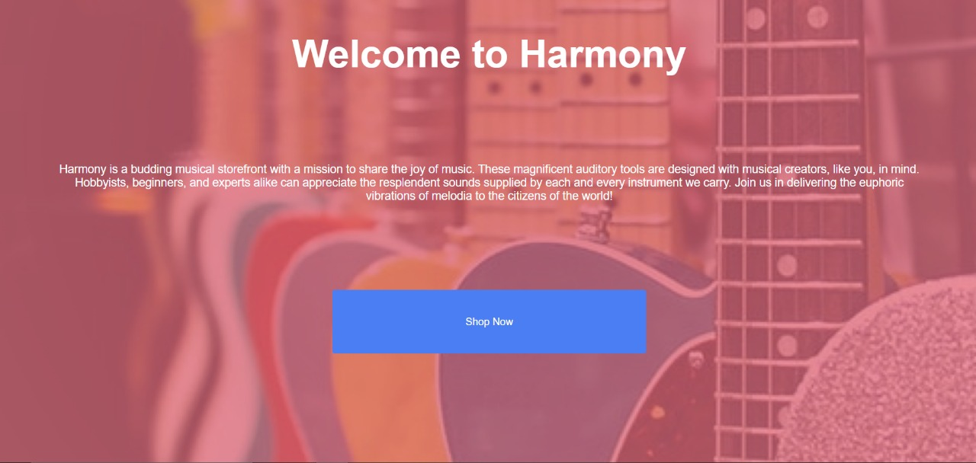

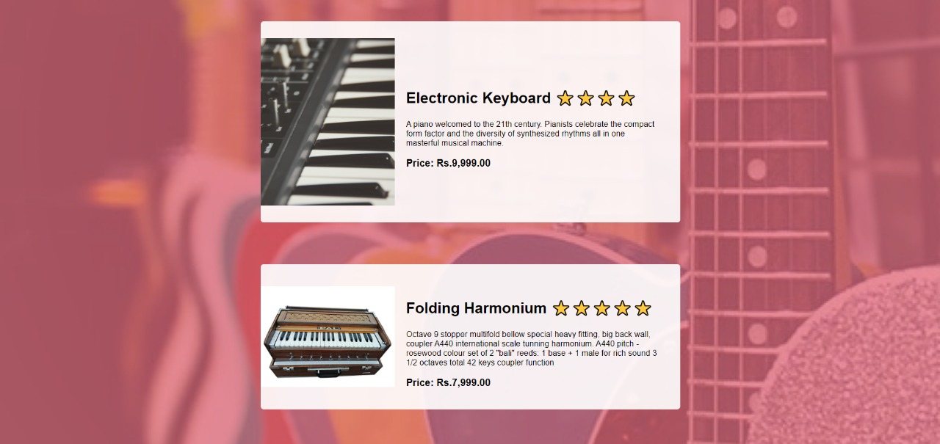

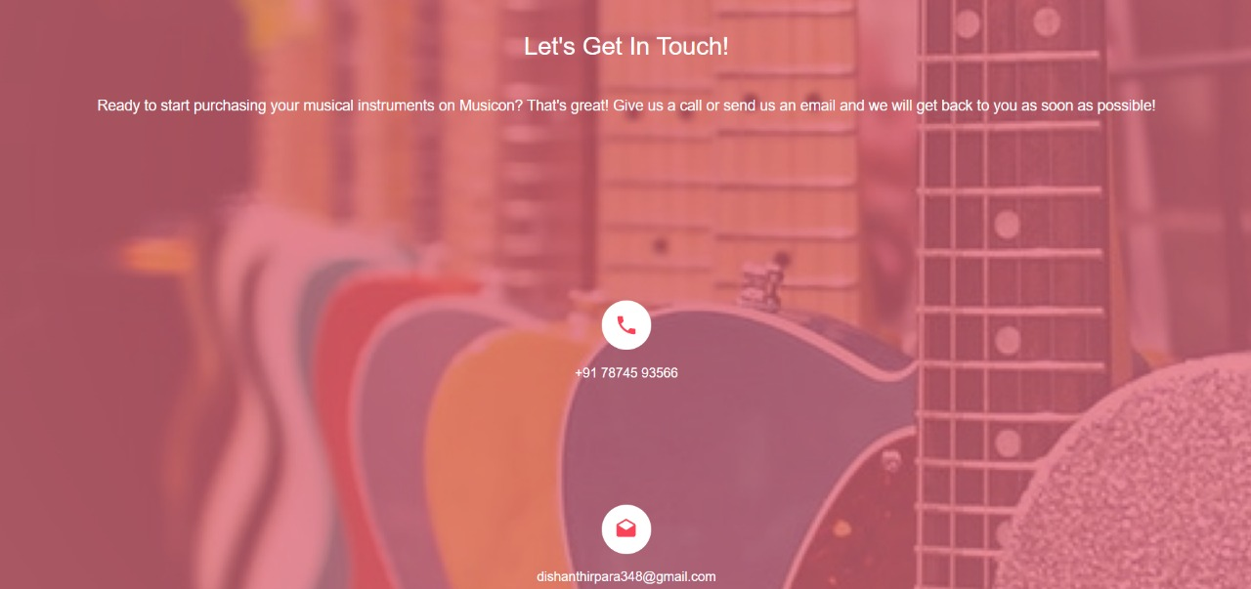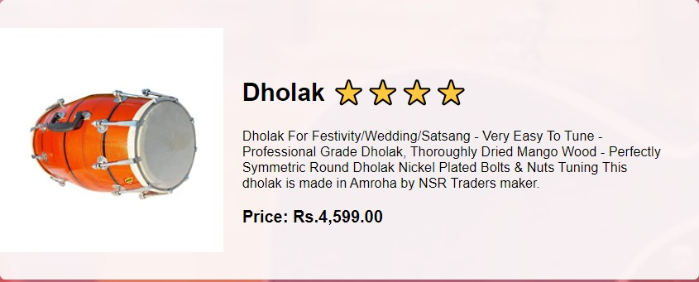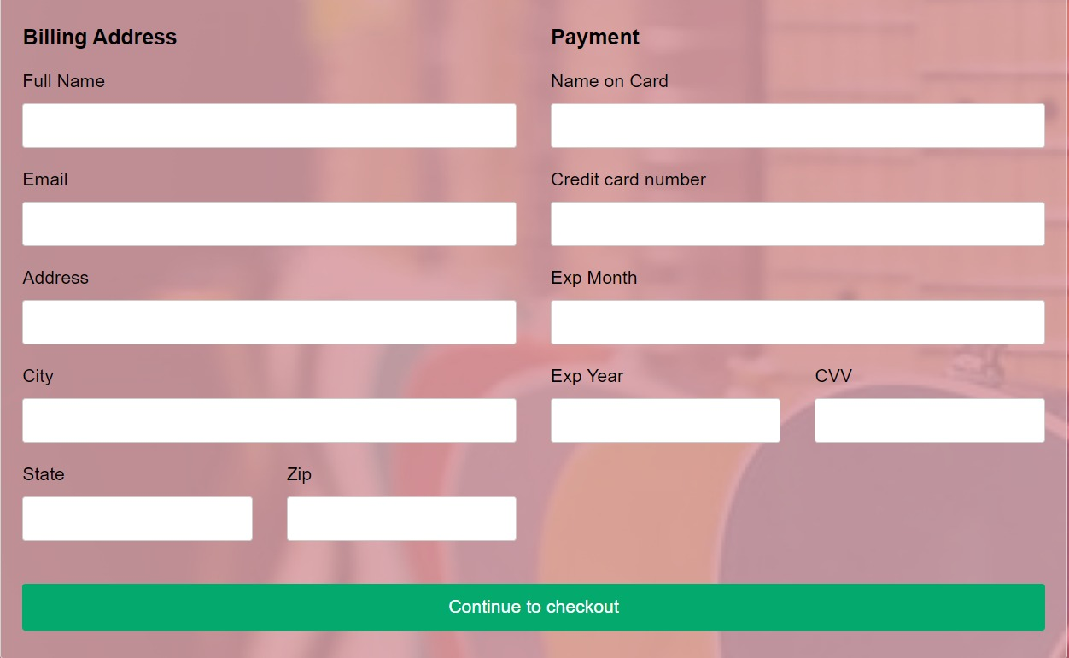

1. **Applications**

. User can view details of the parts without going anywhere.

. It is convenient for users as this system provides accurate cost and description of the system.

. The website is flexible to be used and for e-shopping.

. User can view different categories of product of different brands at a single place.

. The system capable of providing the final price instantly and user can pay online. Hence the system saves time, efforts and cost.

1. **Conclusion**

It has been a great pleasure for me to work on this exciting and challenging project. This project proved good for me as it provided practical knowledge of not only programming in Html, CSS and JavaScript, net web-based application and to some extent Windows Application and SQL Server, but also about all handling procedure related with "Musical instruments shopping website". It also provides knowledge about the latest technology used in developing web enabled application and client server technology that will be great demand in future. This will provide better opportunities and guidance in: future in developing projects independently.

The website displays different kinds of instruments of different brands so users can explore instruments available and add it to their cart. The system calculates the overall cost of the products bought and generates an online bill for the user. User can even make payment online using credit card system. Having paid the bill, user receives an email notification on his registered email id that provides a bill receipt of the instruments bought.